Optiona Handson:VPC +EC2, EBS, AMI – 24/03/2024 -IP Yash + Mahesh

First Create the New VPC and Login to the AWS Console

Give the CIDR as 10.0.0.0/24

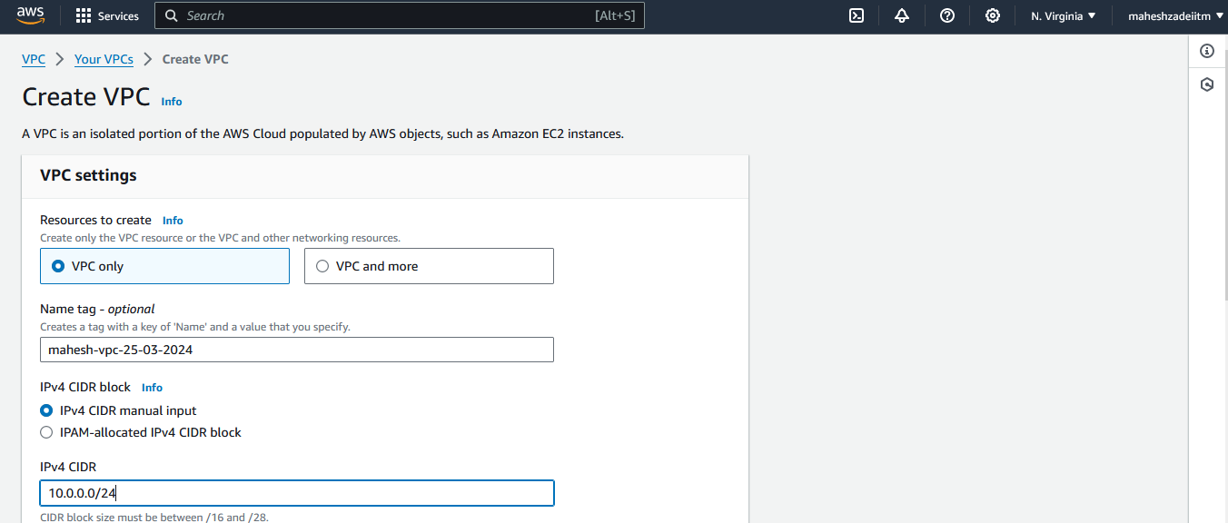

Click on Create VPC

VPC Created

Now create the subnet

Give IPV4 CIDR Block

Create the second subnet

Now crate the 3rd Subnet

By default all the subnets are private , we have to make the Subnet Public by adding internet gateway .

Three Subnet created

Ref Architecture in Class

Now create the Route Table to access the subnet Why to crate a 1 or 3 RT

Reason : There is no way to attached the internet gateway in subnets.

Route Table was created to get the internet access to subnets.

Click on subnet association

Edit subnet association and then save association

Now go to Route and edit route for internet access

Now Need to create the internet gateway

Created internet gateway and attach it to VPC which we created

IGW attached to VPC now

RT attached internt gateway

Go to Sunet and enable public IP to all subnet

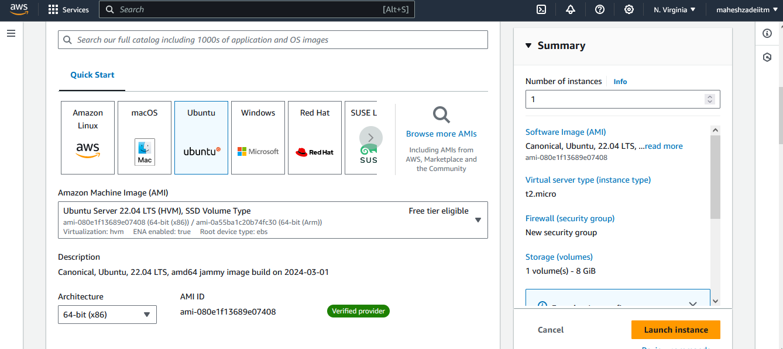

**Downlaod the keypair**

**Edit Network setting s**

**Click on launch Instacne**

**Click on connect**

**EC2 instance Launch in my Custom VPC**

**Thanks you**